Dolphins raid on Hart
Southampton Dolphins Swimmers left their mark on the inaugural meet of the 2018/19 season at Hart Open, coming away with 58 medals, 75 personal best times and 85 Hampshire County Qualifying times.
The award for Top Boy swimmer went to 13 year old Oliver Cook, securing top spot from a chasing pack of swimmers from Staines with nine best ever times and eight top three finishes. The Dolphin girls also sparkled: Jodie Yates (18) was prolific, still improving and bagging five firsts and one silver. Emily Lowther (12) also produced lifetime best times in every event , rewarded with three golds and two silver. Younger brother Matthew (10) rose to the sibling challenge with a massive 34 second personal best in the 200 fly, over 10 seconds improvement in the 200m backstroke, four other golds and a silver medal. Nathan Lewis (11) impressed with nine podium placing’s, 50m free (31.7) and 50 breaststroke (42.62) earnt gold for excellent new times, the individual medal reflecting his overall stroke technique improvement, shaving 8 seconds from his previous best time. Sister Ellena Lewis couldn’t match the medal count but everyone was delighted with her breakthrough times in 200 Individual Medley and 50m breaststroke. Nine year old Shirley schoolgirl Ruby Latimore destroyed the field and her previous time for two lengths butterfly by over 20 seconds to earn Gold. Sister Freya (11) kept the medal tally up with her five improved times, the 50m backstroke (35.95) good enough to top the podium. Freya Manning (13) picked up gold in 50m backstroke, Rhyseren Taylor was first home in the 400m freestyle for twelve year girls, second in 200m fly and sliced 6 seconds off her best time to take silver in the 400m IM. Evie Turner also cut her time dramatically in the 200m IM while twin sister Isabel medalled four times, improving 50m back (33.67) and 200m IM (2.41.41). Zak Lanham rounded off a fine calendar year of racing with five medals, a gold in the 50m fly (30.03) and four more new best times.
The new Dolphins Performance Coaching Team of Paul Dollery and Hugo Marreiros under the guidance of Matt Boyd Wallis has had a major impact on the club’s approach to competitive swimming, introducing a high level of long term technique training and quality pool time.
The team from Shirley Pool won 21 gold, 24 silver and 13 bronze medals in total and Southampton Dolphins Head Coach Matt Boyd Wallis was pleased as punch with his young squad:
“We had a total of 115 swims across all age groups, from 9 to 18 years and over. This was our first Open Meet of the season and what an amazing weekend it has been. I am incredibly proud of all the Southampton Dolphins who competed this weekend, we had swimmers performing their best, supporting and cheering on their teammates. Everyone should be very proud with what they have achieved from this competition, with swimmers racing for the very first time at an Open Meet, to those who won medals, recorded PB’s and gained County Qualifying times. “
Other PB’s from:
Mali Belward
Girls 13 50 Breast 51.18
Girls 13 200 IM 3:45.40
Girls 13 100 Back 1:42.32

Maisie Latham

Girls 12 100 Breast 1:42.23

Girls 12 50 Free 37.01

Girls 12 200 Breast 3:39.12

Pippa Read

Girls 13 50 Free 34.98

Girls 13 50 Breast 49.00

Girls 13 100 Back 1:25.95

Girls 13 100 Free 1:19.08

Isla Rutherford

Girls 10 50 Back 42.71

Girls 10 50 Free 36.86

Olivia Tilley

Girls 14 50 Back 36.52

Girls 14 100 Breast 1:30.78

Girls 14 50 Breast 40.81

Girls 14 100 Back 1:16.97

Girls 14 100 Free 1:12.59

Zoey Yates

Girls 12 100 Breast 1:41.50

Girls 12 50 Free 33.36

Girls 12 50 Breast 44.99

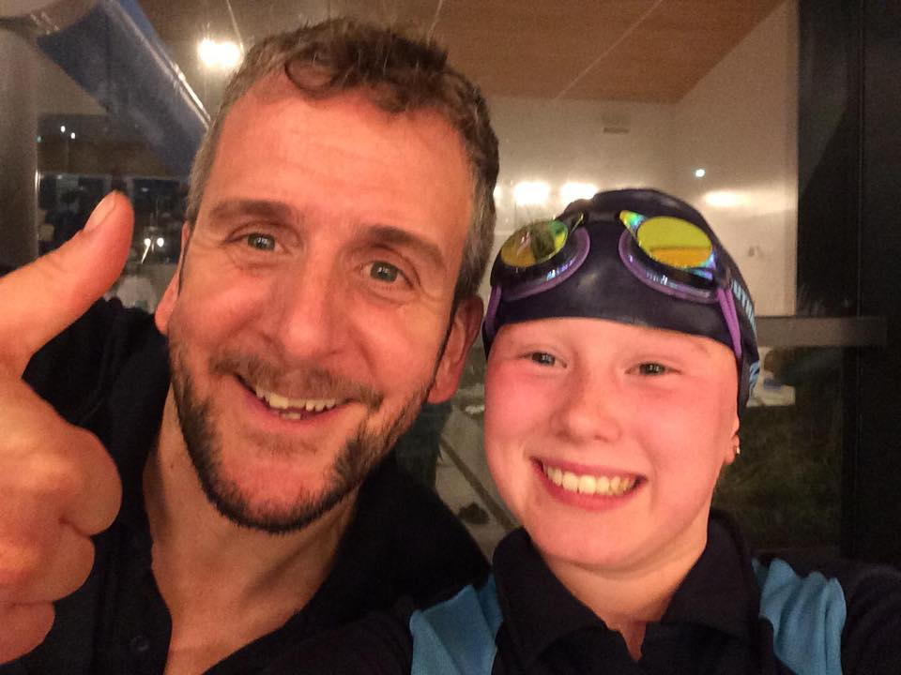

Head Coach Matt Boyd Wallis with “ Marvellous Maisie” Latham

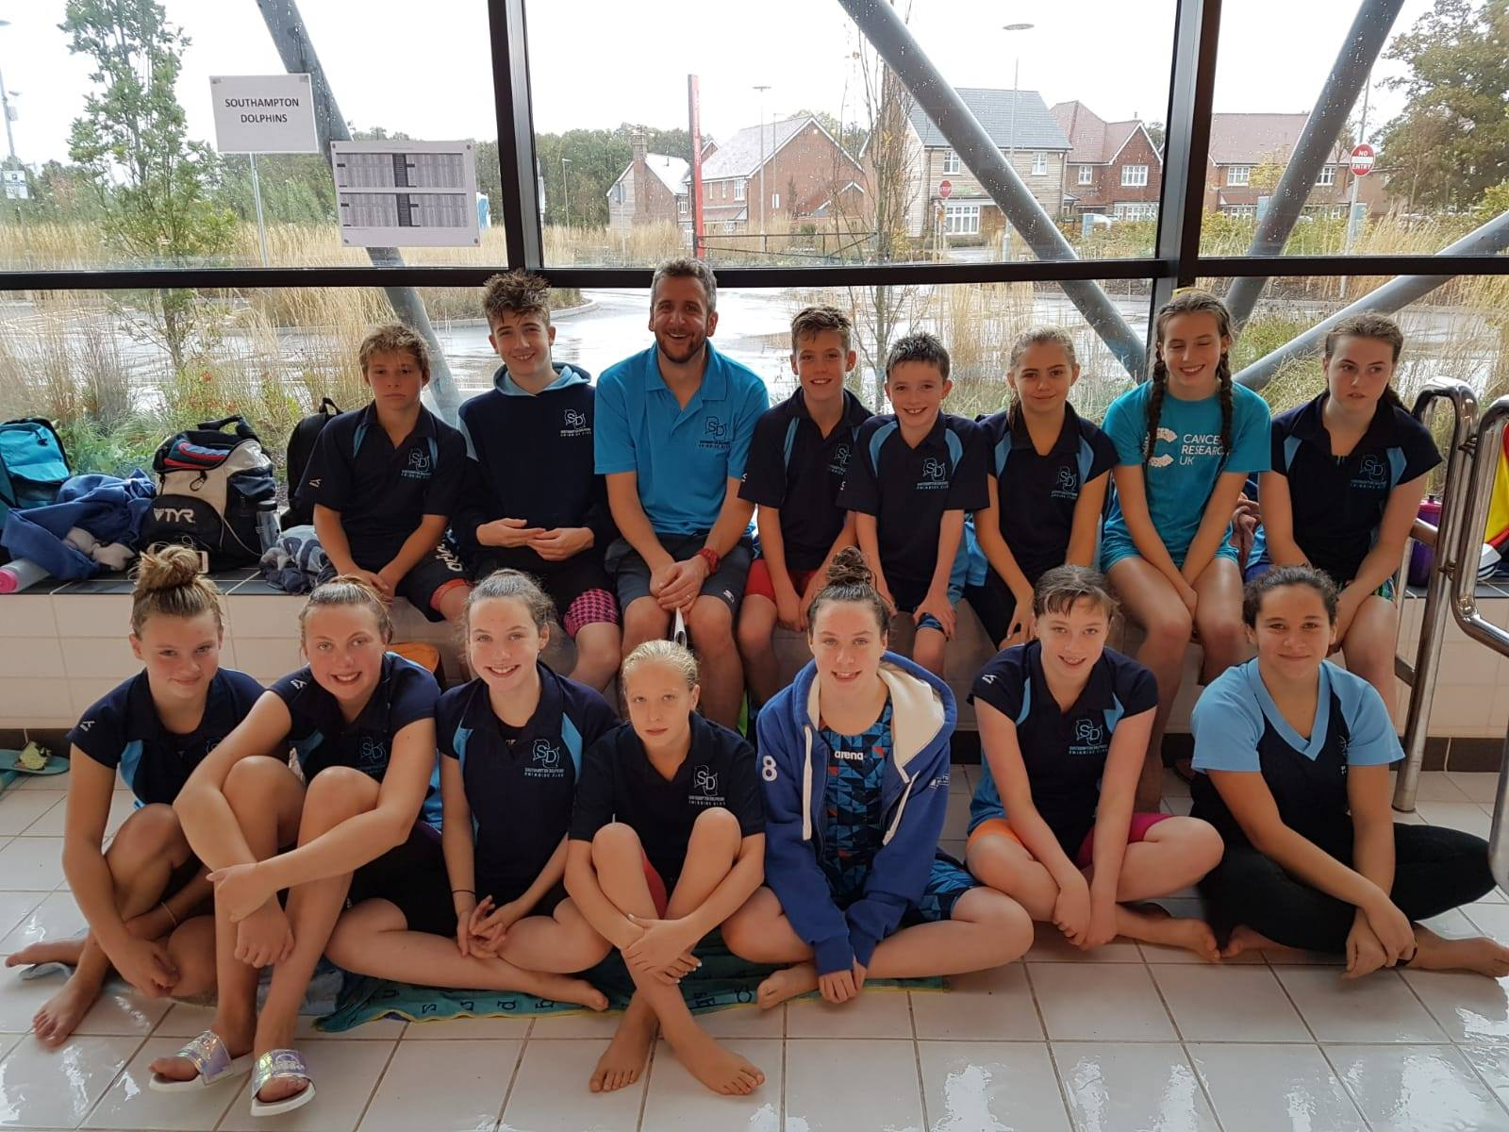

Head Coach Matt Boyd Wallis with the Dolphin Swimmers at Hart Open Meet

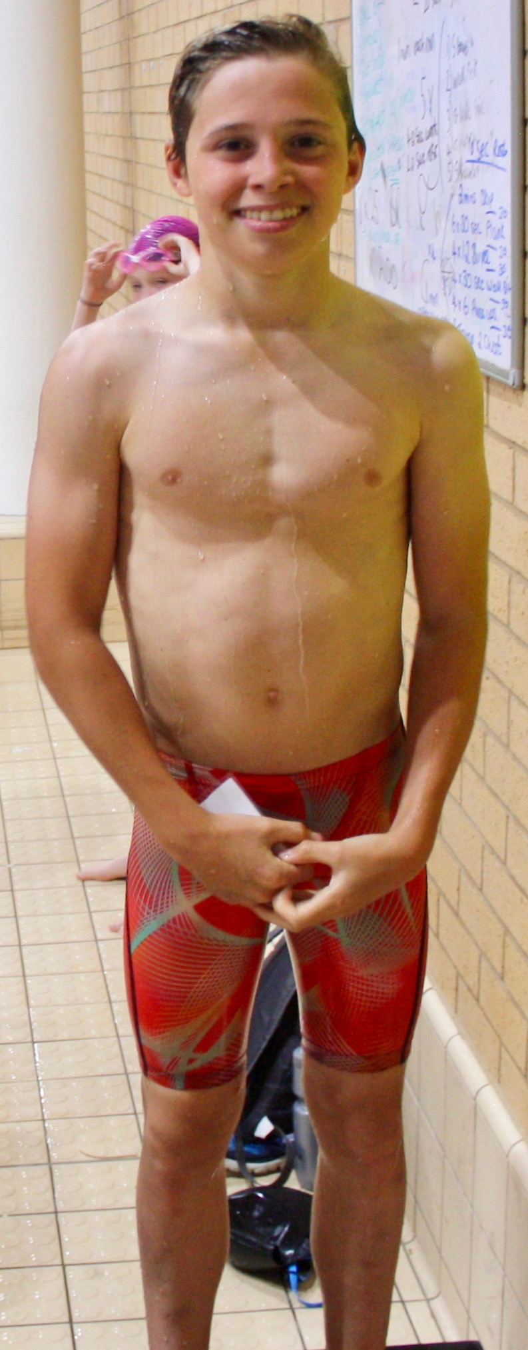

Top Boy Oliver Cook

