Coach Richards
After attending schools in the UK, Indonesia and Thailand, I grew up thinking that change was normal and that moving continents wasn’t a big deal. After studying Sports Coaching at University, I had written out an ambitious career timeline studded with major goals up until my retirement. The reality was that I was encouraged to move to America to seek the best experiences and mentors, as it was felt that the pathway for young coaches in Britain at that time was limited.

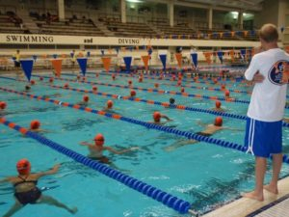
Auburn Swimming with Richard Quick and Rowdy Gaines

As a headstrong, outspoken, independent 21 year old filled with the dreams of becoming the next Teri McKeever, I boldly landed on the doorsteps of Auburn University ready to take on the world – how quickly that raging fire was contained!
I finally secured a full time Graduate Assistant position with a Division One College.
In the space of a few years I had come into contact with numerous head coaches, all with completely different coaching and teaching styles, methods, strengths, weaknesses and philosophies. I also had the honour of coaching hundreds of different athletes of varying standards, from different backgrounds, in a variety of different academic institutions. I went away from each encounter having seen and heard something different. Whether it be positive or negative, there was always something to learn. Nowadays, one of my biggest nuggets of advice when mentoring coaches is to experience as many different coaches and scenarios as possible. There is always a teaching point to take away when you observe someone, even if it’s just to remind you that you are doing the right thing.
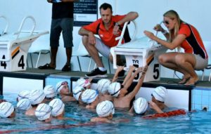
Rachel coaching in Singapore

After four years as a Graduate Assistant, I interviewed for a head position in a strong and well respected international school in Singapore. It would be a start-up programme, a blank canvas

Determined to make the programme a success and establish myself as a head coach at 24 years old, I brought all of the dynamic, emotive, animated behaviours I’d picked up from America and set about creating a culture change. The school had long standing traditions and initially resisted change. I asked swimmers and their families to buy into a world of chanting, team bonding, face paints and 100% commitment. I ended up starting up two programs during my five years in Singapore and I adopted the same strategies in both.

The key to both was ‘buy in’, creating a culture shift and getting swimmers and their parents to ‘buy into’ this young, loud, over-confident, ‘Americanised’ coach and her ‘new’ ways of training and managing a programme. I was extremely fortunate to inherit an amazing assistant who completely picked up what I was putting down, and he backed me to the hilt. Asking teenagers to commit to 8 water sessions a week (compared to the 2 rugby or football sessions that would automatically get you ‘cool’ status) was a challenge. I came up with a two-pronged attack; 1. To educate the parents on the benefits of competitive swimming; 2. to make the training environment and the sport of swimming the most fun place to be.

Educating Parents on the Benefits of Competitive Swimming

Why swim? As a parent, the demands are huge and for the child they are even more so. Early mornings, late nights, and weekend meets all put pressure on the entire family – and you can’t forget the amount of food consumed! You all know the benefits of this sport, otherwise you wouldn’t be dedicating your life to it – so we need to educate our parents to the many positives that outweigh all the challenges.
This is when I first came across Carol Dweck and ‘Positive Education’. Without writing another essay for you, I am sure most will be aware of her work now, but if you are not, I encourage you to google it. Teaching parents about “growth vs fixed” mindsets were essential to their understanding of what we were trying to achieve.

Making the training environment and the sport of swimming the most fun place to be

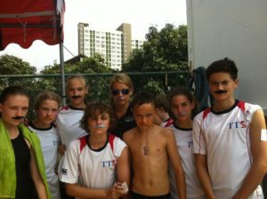
Making the sport fun and relatable to kids is important!

1. Don’t take yourself or the sport too seriously…

Of course, we all do. I more than anyone believe the world would end if I was not able to be a swimming coach! But allowing yourself to be ‘human’, silly, goofy and a big kid with the swimmers was one way of getting kids on-side. They wanted to spend time with us, so staying on top of current trends was important then and is even more so today.
In order to better engage our kids, we endeavoured to think outside the box and use our space creatively. We incorporated dryland sets into our water sessions, while using team games to keeps kids on their toes, help them interact, and help them to get even fitter.

Teaching swimmers about energy systems is necessary, however. Once they have the understanding of these concepts there is no reason why you have to use the same scientific language when delivering sets. So we made up our own words, kept things original and unique to our team. This is just one example of how we made swimming relatable and the environment fun.

2. Establish relationships

This topic is controversial and not everyone will agree that you need to get along with your athletes to have success. I don’t believe that every coach will connect with every athlete. However, I do believe that some coaches connect with athletes better than others and that athletes will perform better for a coach they feel more connected to. I have no doubt that people will argue this and may contest that I am too emotionally invested in my swimmers, but truthfully, I wouldn’t know how to coach any other way. I feel that I truly ‘know’ my athletes. I can see when they have had a good or bad day, when they need tough love or an understanding shoulder. They trust me with their emotions and that holds great responsibility. Creating an environment where they felt safe, supported and could be their authentic selves made them want to come swimming every day.
3. There is no “I” in Team

It’s corny but true: showing athletes that there was a bigger picture, that they contributed to something more than their own individual success gave them a reason to come training every day. Creating a ‘team’ where everyone feels valued is one of the key ways of creating ‘buy in’. Learning about each other and creating opportunities for children to interact with different ages and genders makes for team cohesion. Get them out of the pool, and short term pool time loss is made up with the long term gain of a close supportive team.

This is where we could create better habits and a performance atmosphere based on modelling behaviours. If you are late, you are saying to your teammates and coaches that your time is more important than theirs. So, be punctual. Basic lessons are essential.
4. Create accountability

From small things like “pack your own bag!” to harder lessons where swimmers are able to call each other out, this was one of the major things I learnt from Richard Quick. Teaching children that constructive and well-delivered criticism is not personal but is there to help you is huge
When children feel they are in a safe environment and feel valued, no matter what their ‘ability’, they are more inclined to say to a teammate ‘Hey, I know you can finish harder than that!’, rather than fearing they may receive a negative response. The swimmer who was the subject of that comment, can choose to take it in a positive way to make sure they finish better on the next interval and not take it personally. Too often we see a ‘put down’ culture in sport and a hierarchy of athletes, which can create animosity between ability groups and cause a split in teams.
Creating this safe environment is a long process and takes a lot of effort but the results can transform a team. All of a sudden athlete are holding each other and themselves accountable and the standard of the team rises dramatically.

5. Shape the box to fit the team, not the other way around

Too often the reason we do things is because they have always been done that way. It was important for us to find out why kids wanted to play another sport over swimming or why parents didn’t want to attend a two-day swim meet. A major challenge we kept facing was how much time swimming took up.
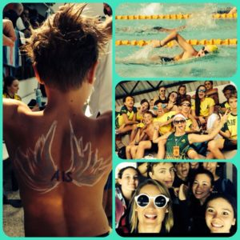
Learning how build team relationships takes time, but creates a strong community.

I can completely sympathise with the parents that sit on a hot pool deck for 2 days straight, only to watch their 9-year-old child do a 200m Breaststroke in over 5 minutes and then get disqualified! How is that a positive experience…for anyone?! I get the Dad that then turns around and says ‘we’re playing soccer on Saturdays instead’, far better! We all know that a crucial factor to American swimming success is the collegiate system, and one key element is dual meets. They are fast, fun, hone race skills, create team culture and make us practice what we need to do: swim fast. So, I emulated this on a school level by introducing a citywide inter-school swim league.
Fast forward 5 years and both these school programs grew to around 300 competitive swimmers and I’m delighted to see many of the original kids still enjoying the sport.
My time in Singapore was invaluable and I created teams I was completely invested in, but I was once advised ‘never to stay in a program purely for the kids’. As tough as it is to leave some of those relationships behind, you ultimately need to keep moving forward. One of my beliefs is that you will have done your team a disservice if you cannot leave your team to be coached by someone else. Initially it may be hard for them and for you to move on, but ultimately you want to create coachable, well-adjusted athletes that have a toolbox of skills they can use without you.

Moving back to England after 10 years away was a major decision, but I craved professional development and to be challenged by swimmers, so I jumped at the opportunity of moving to ######. I literally fell back into the reality of club coaching with a very hard bang! Fighting for pool time, having a volunteer committee and volunteer assistant coaches, learning the new structure of England and British swimming – I suddenly felt like a junior coach again. With no professional support network, standing on deck at meets knowing literally no one was incredibly daunting at first. It’s taken a full season for me to really understand how the program works, where it lies within the structure of the region and country, get to know all the swimmers and figure out what makes these kids tick. At the moment the box is always changing shape.

So how does all this background now help me with the biggest professional challenge I face? If you have managed to keep reading I hope I’ve been able to get across my underpinning values and philosophy. These really have not changed. Despite the calibre of swimmer being higher, I ultimately want to foster an environment where these kids choose to be. A happy swimmer will make a faster swimmer.
“Fundamentals”, “Discipline” and “Consistency” work in a triangular effect and I do not believe you will be successful without all three.
Fundamentals:
Fundamentals are important in everything – from what happens outside of the pool (being a good teammate, being punctual and setting goals) to the detail of what happens in the pool (starts, turns, finishes, eliminating drag and focusing on how YOUR body sits in the water). Never forget the small details, look for the marginal gains and find that extra 1%.

Discipline:
Be accountable for yourself and your team. Make sure you as a coach model the correct behaviour and show your athletes what long term development looks like. Educate your swimmers on being accountable and create teaching moments that they can bring into other areas of their lives.
When the discipline in the pool slacks, whether it be not holding on to their skills at speed or not turning up on time – stop everything immediately and correct the behaviour.
Consistency:
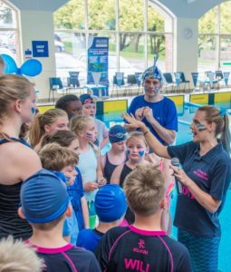

There is no point in doing any of the above things once or even just once a week. The key is to be consistent with the messages we send to our swimmers. The team must know the expectations, they must know what is required of them and they must do it consistently. This will eventually create habitual behaviours. Once these behaviours are established you can move the goalposts further away and extend their limitations again. By showing them what the process is, they will eventually reach the desired outcome.

We have only just scratched the surface of what we can achieve.

