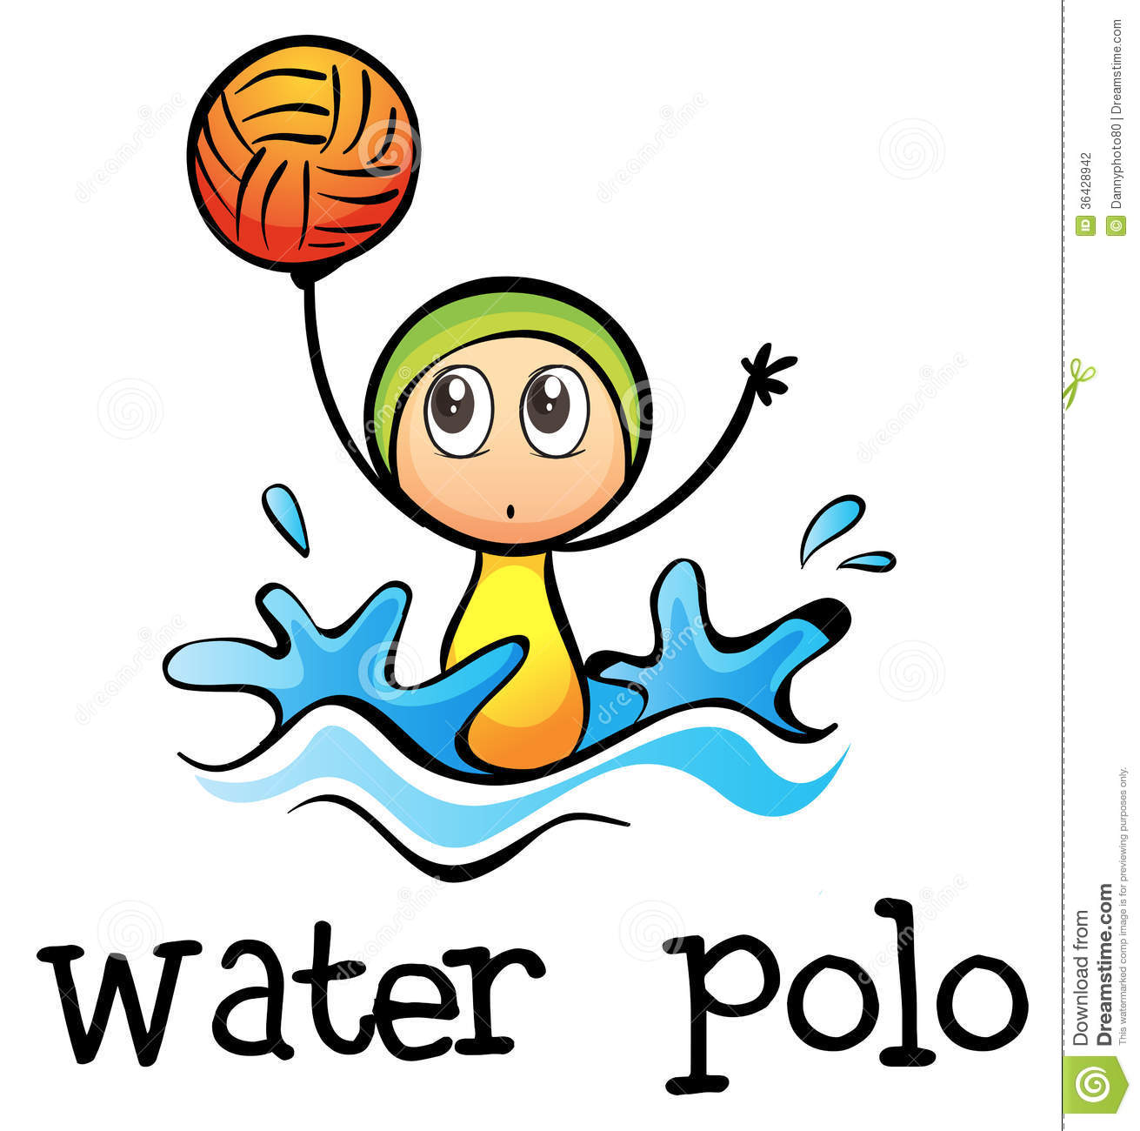

Tournament Entry Form

Saturday December 9th 2017
5pm – 7pm

Name ………………..

Age……………………

Which group do you swim in?....................

Do you have a team? What’s the name………………….

