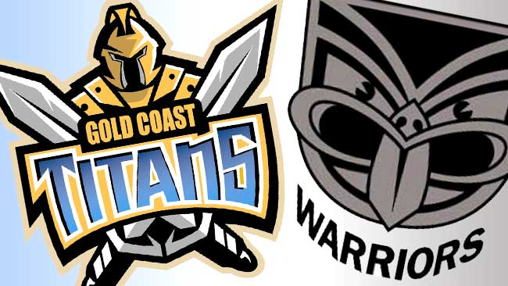

Titans V Warriors
Saturday November 11th 2017 5pm -7pm

Swimmers Name………………………………..

Age on November 11th………………………….

Current swimming level………………………
(Fly, Turtles, Penguins, Academy, Club)

Favorite Stroke………………

Fly
Back
Breast
Freestyle

